TRANSFER OF WOUND CARE
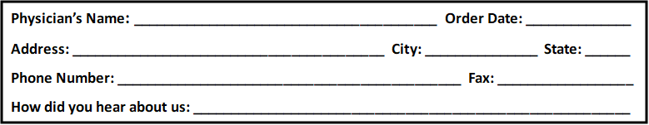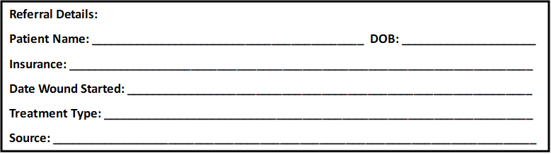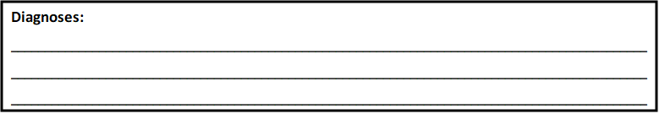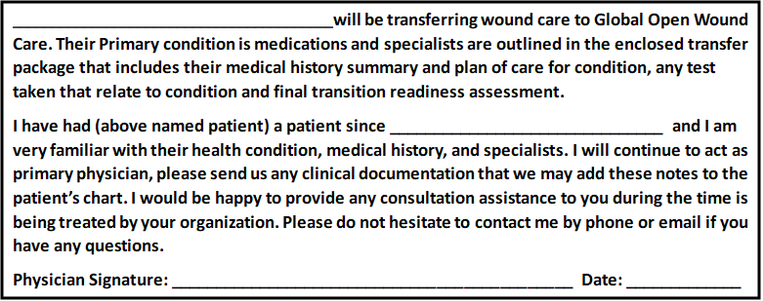 Please Fax or Email: 469-574-7757
southwestcentralwoundcare@swwound.com
- Transfer of Care Form
- Demographic page with insurance information attached.
- All office note pertaining to wound care services plus medical history.
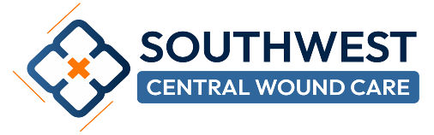
- Provide images of the patient’s wounds if applicable.

